# Title: On “Галерея” page. While navigating through the gallery images, we can see many “technical” texts.

**Priority:** High

**Severity:** S4 Minor

**Environment:**Google Pixel 7 Pro (3120×1440, Android 11 OS). Tested via Android Studio.

**Steps to reproduce**

1. Open the Main page: [https://zpolis.com.ua](https://zpolis.com.ua/)

2. Click on the “burger-menu” on the left upper-corner of the screen.

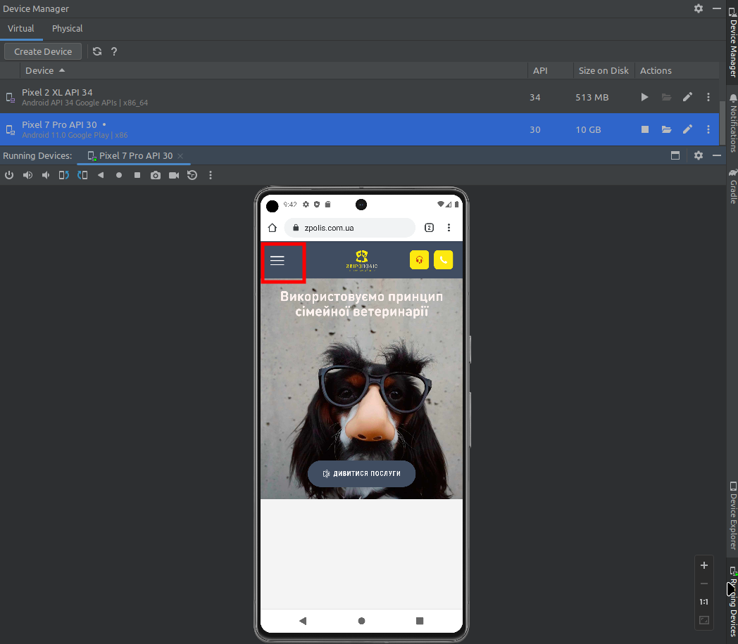

3. On an opened menu c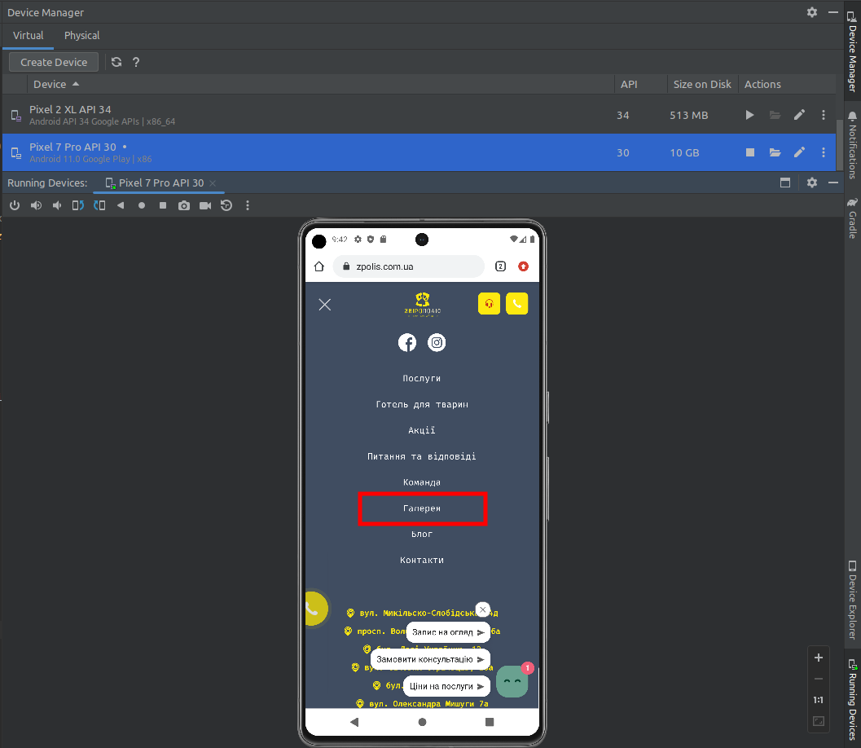lick on “Галерея” word.

4. On an opened page click on a picture with dogs by “Наші щасливі клієнти” section.

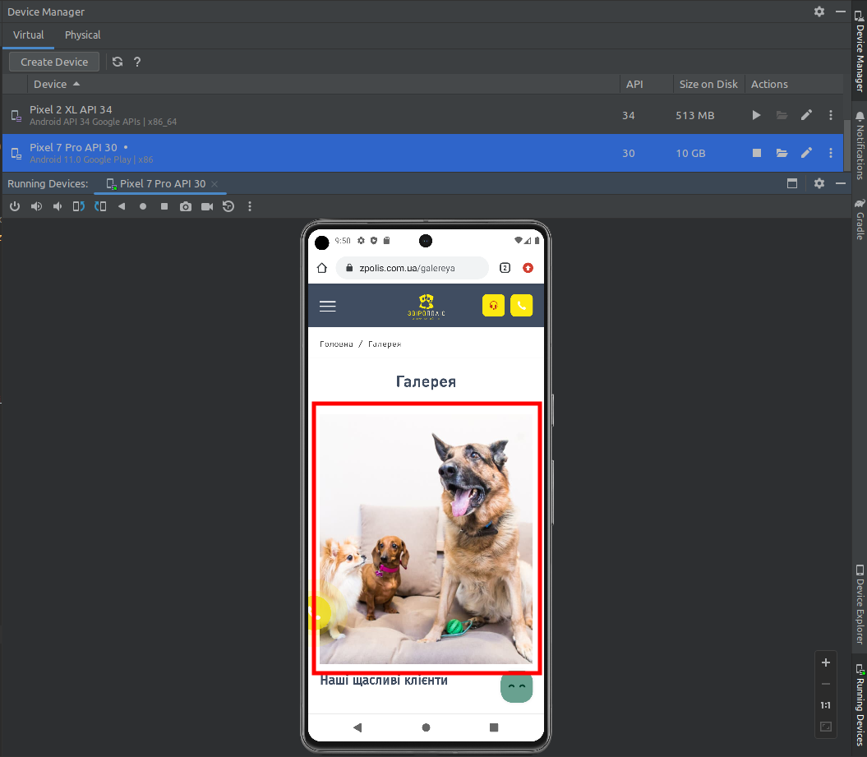

**Actual result**

We can see many “technical” phrases under some photos.

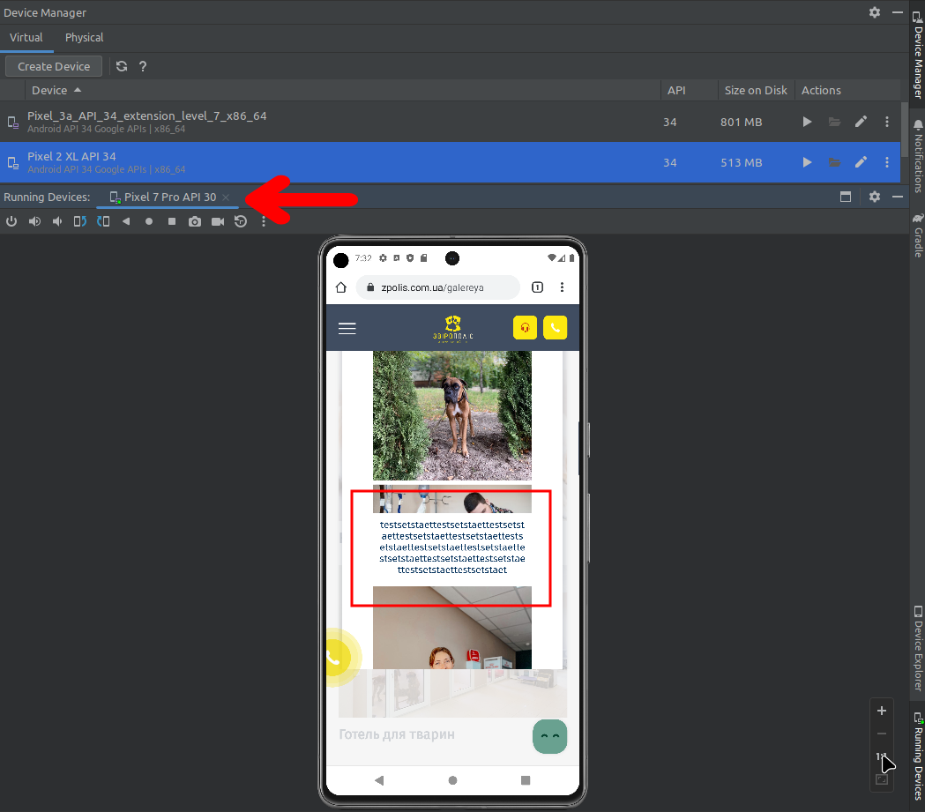

**Expected result**

These phrases must be deleted or changed to relevant descriptions under the photos.

*Screenshot from* ***Jira****:*

